CSC1139/1111 Mathematical Models/Computational Science
In-Class Exercise 5

Advanced Model of Univariate TS

Exercise to Assess ACF of Various Series, AR Model, MA Model:

- Below are the ACF and PACF for three time series. For each series, state whether it is
autoregressive or moving average, and the order (p or q).
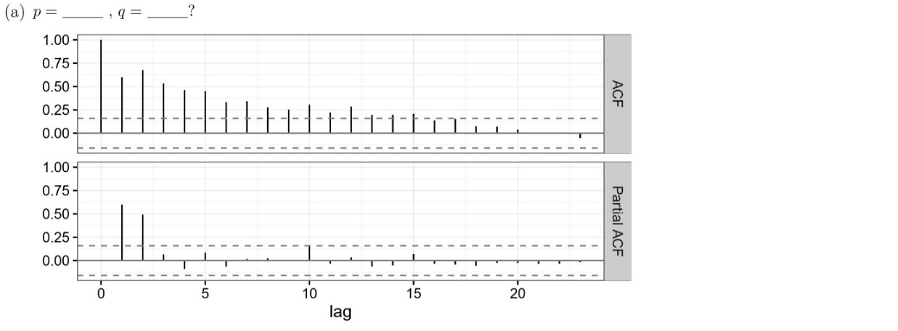
Answer: p=2, q=0
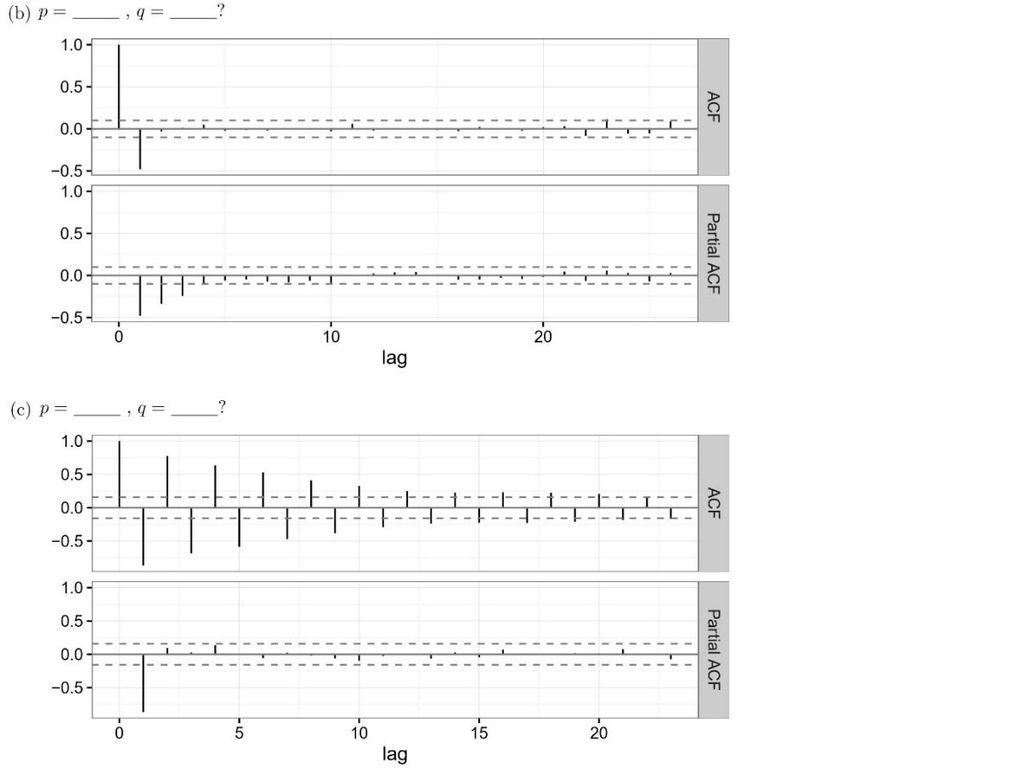
(b) Answer: p=0, q=1, negative coefficient, (c) Answer: p=1, q=0, negative coefficient
- The following plots show examples of (theoretical) ACF for a variety of ARMA models. In each case, give the simplest possible description you can of the underlying model.
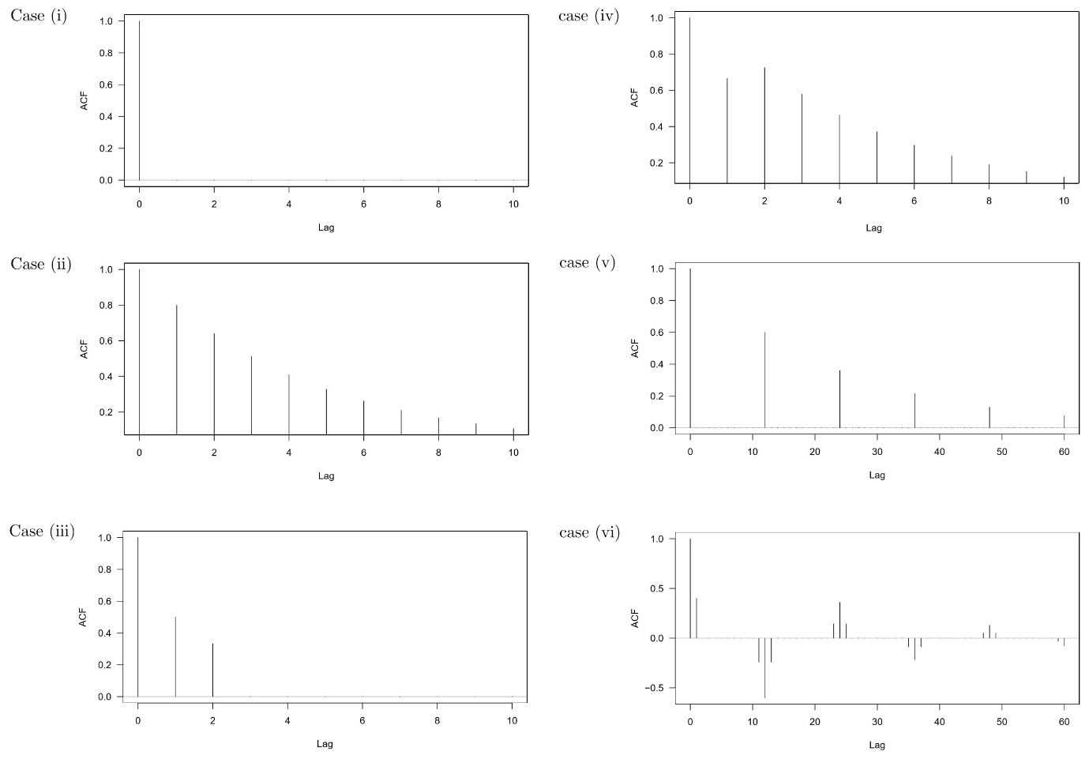(i) White Noise
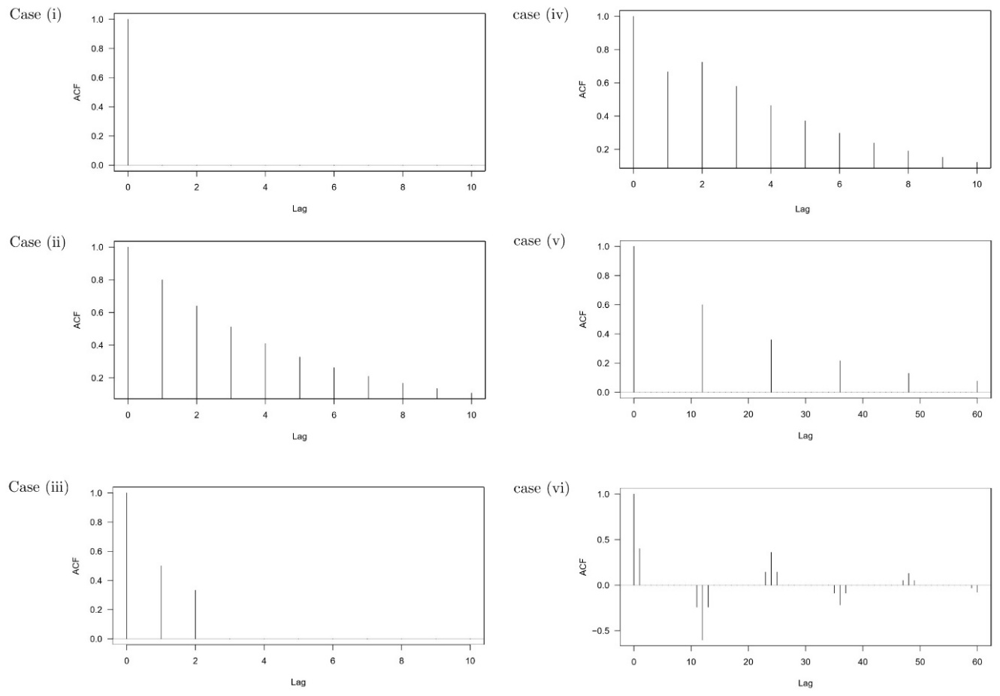
Answers: (ii) ARMA(1,0), (iii) ARMA(0,2)
- SARIMA Sample Questions
- Answer ar=0.3, sma=0.5
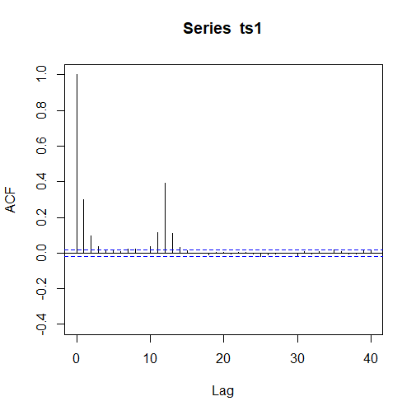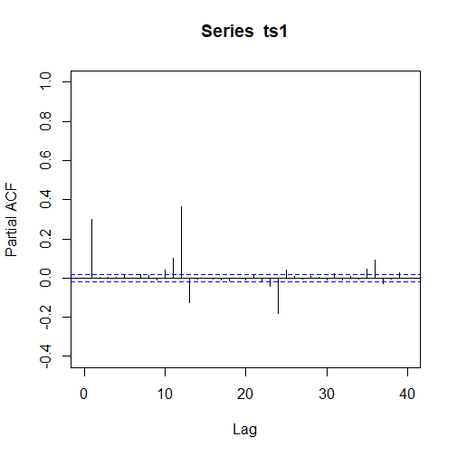
- Answer: ar=0.4,0.2, sar=0.4
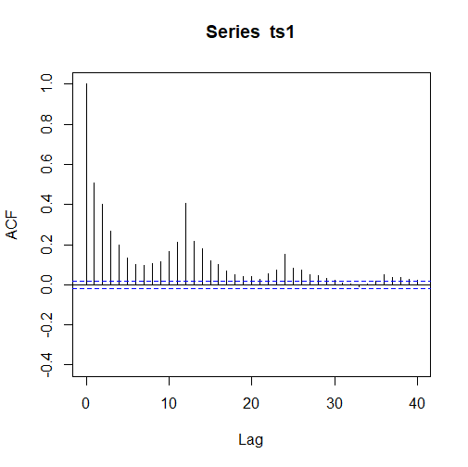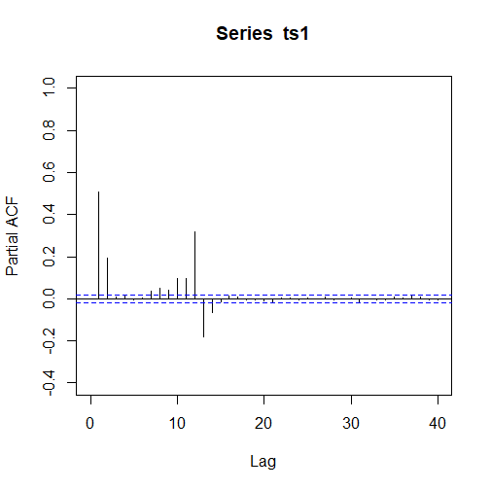
- Worked Sarima Example Air Freight
  - First load the necessary libraries
library(forecast)
library(tseries)
library(stats)

  - Take in the data case9.dat and convert to a time series object in R
data=scan("case9.dat")
case9=ts(data, start=c(1969,1), end=c(1978,12), frequency=12)
# case9
  - Next, plot the case9 series, ACF and PACF. This is best done with ggtsdisplay:
ggtsdisplay(case9,main="Air Tranport Data",lag.max=40)
  - Next, check the variance by eye. If it needs log transforming, do it.
  - Do a ggtsdisplay again on the resultant series, this time you are seeing whether you need to do differencing (regular or seasonal) using diff(series,lag)
    - Hint: it should need both to be done.
  - Do a ggtsdisplay again on the resultant series to see what the P/ACF look like
  - Check the Augmented Dickey Fuller
    - Firstly, using adf.test(series)
    - Then, using adfTest(series) from fUnitRoots
  - Check your residuals using:
(fit <- Arima(log(case9), order=c(x,y,z), seasonal=c(X,Y,Z),include.constant = FALSE,lambda=0))
checkresiduals(fit)
You will need to fit values to x, y, z, X, Y, Z here

